Hinduism

Aum

Shiva

Ganges

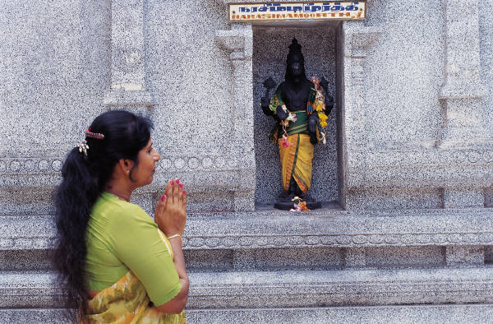

Mandir

Deepawali

Ganesha

Sikhism

Guru Nanak

Kirpan

Guru Granth Sahib

Kangha

Chauri

Nishan Sahib

Buddhism

Bhikshu

Buddha

Stupa

Dharma

Bodhi Tree

Incense

